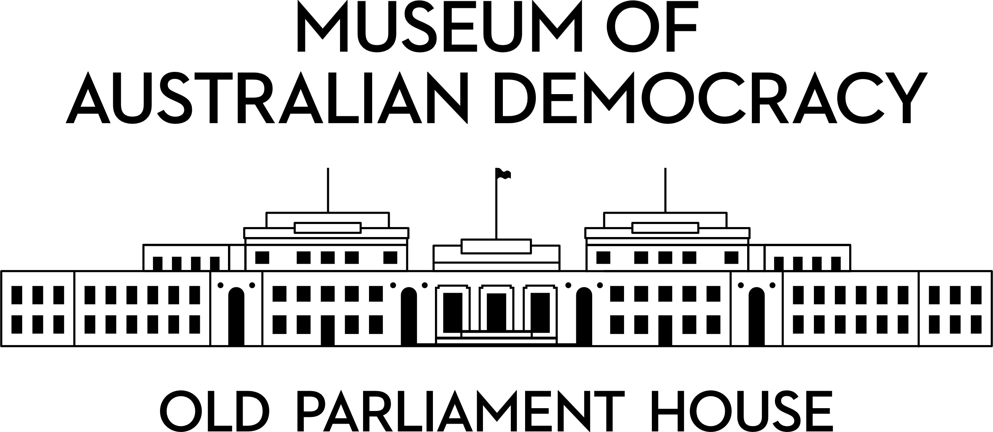

**CANDIDATE PACK**

|  |  |
| --- | --- |
|  | |
| **POSITION DETAILS** | |
| **REFERENCE NO** | New Position |
| **TITLE** | Senior Curator – Power Dressing |
| **CLASSIFICATION** | Executive Level 1 |
| **EMPLOYMENT TYPE** | Non-Ongoing |
| **WORKING HOURS** | Full-time |
| **OFFICE ARRANGEMENT** | Onsite with some work from home considered |
| **SALARY** | $115,443 - $125,832 pa +15.4% Superannuation |
| **SECTION** | Interpretation and Curatorial |
| **TEAM** | Curatorial and Interpretation |
| **ELIGIBILITY** | * Australian Citizenship * Security Clearance (after commencement) |
| **CONTACT OFFICER** | Ashley Tenison (02) 6270 8148 |
| **OPENING DATE** | Wednesday 27 August 2025 |
| **CLOSING DATE** | Tuesday 9 September 2025 11:59pm |
| **SPECIAL NOTE** | This is a non-ongoing specified task opportunity until completion of the Centenary project in 2027. |

**ABOUT US**

The Museum of Australian Democracy (MoAD) at Old Parliament House is located inside a heritage-listed building that was once home to Australia's Parliament (1927 to 1988).

True to our building’s original brief, we provide a ‘people’s place’, where big ideas are explored.

We share the story of Australia's democracy through exhibitions, events and education programs, as well as through our rich online collection of stories, objects and resources.

At MoAD, we celebrate the Australian democratic journey. We seek to provoke thought and inspire conversation by sharing stories and objects that played a part in shaping the nation as it is today.

Careers at MoAD are varied, from human resource officers, exhibition curators, heritage officers and learning facilitators, to digital producers, finance officers and IT specialists. We are a small agency, working in a dynamic environment, sharing our democratic and political history in a heritage-listed building.

MoAD is an inclusive and rewarding workplace that values the contributions of all our staff. We encourage applications from First Nations Australians, people with a disability, culturally and linguistically diverse people and LGBTQIA+ people. We are committed to a safe and supportive workplace which includes flexible working practices.

MoAD employees are engaged under the [*Public Service Act 1999*](https://www.legislation.gov.au/C2004A00538/latest/text) and are subject to the terms and conditions of employment in the [*OPH Enterprise Agreem**ent 2024-2027*](https://moadoph.gov.au/sites/default/files/2024-04/oph-enterprise-agreement-2024-2027.pdf)*.*

**POSITION DETAILS**

Old Parliament House will mark its centenary in 2027 and MoAD is developing a suite of programs to mark the anniversary. The Centenary program will include a major new exhibition, Power Dressing (working title), which will examine how clothing can communicate political ideas. Power Dressing will not just be about fashion; it will consider the relationship between clothing choices and expressions of democracy.

The Senior Curator – Power Dressing will lead a small team to develop and deliver this exhibition. Drawing on their subject matter expertise, they will work with creativity and flair to deliver an engaging experience for MoAD’s onsite and online visitors. Our ideal candidate will be an experienced museum professional with a background in Australian history and the history of clothing, textiles and fashion, and a strong awareness of the relationship between fashion and power.

The Senior Curator will have the ability to inspire others with their vision for the exhibition. The role requires sophisticated stakeholder management skills, including the ability to represent MoAD with a high level of professionalism, orally and in writing.

The Senior Curator will work collaboratively with colleagues across the organisation to ensure the timely delivery of quality projects.

**ROLE RESPONSIBILITIES and DUTIES**

Under the direction of the Head, Curatorial and Interpretation, the Senior Curator – Power Dressing will be required to:

* Deliver the Power Dressing exhibition for the centenary of Old Parliament House in 2027.
* Research, write and develop content for onsite, online and outreach programs and lead pro-active collecting efforts.
* Manage a small team of curatorial staff to deliver high quality outputs for the Power Dressing exhibition. Support staff development.
* Work closely with community representatives (including potentially First Nations representatives), consultants and other internal and external stakeholders at all levels. This will include developing productive relationships to secure loans for the exhibition.
* Represent the museum in a range of formats and forums including through writing and verbal presentation including to the media.
* Work collaboratively with all sections of the museum and as a member of the section’s senior leadership team to support centenary projects.

**OUR IDEAL CANDIDATE**

* Relevant tertiary qualifications with a demonstrated interest in, and knowledge of, Australian history and the history of clothing and fashion, with particular reference to the relationship between fashion and power.
* Exceptional stakeholder management skills with a track record of developing productive working relationships with internal and external stakeholders.
* Knowledge and experience applying museum practices and procedures with demonstrated curatorial experience and exhibition delivery within a museum or gallery.
* Excellent communication (written and oral), presentation and interpersonal skills.
* Ability to work both independently and as part of a team to creatively solve problems, work with a high degree of flexibility, and ability to set priorities, meet deadlines and work to a budget.

**YOUR APPLICATION**

Please provide a:

* concise statement of claims of no more than 2 pages. When framing your statement, please ensure you adequately demonstrate your skills, qualifications, experience and capabilities.
* Resume outlining your career history, qualifications and contact details for at least two recent referees (no more than 4 pages).
* coversheet from the [MoAD Website](https://www.moadoph.gov.au/about/careers).

MoAD accommodates requests for reasonable adjustment for people with disabilities to participate in an interview, including offering onsite tours to potential employees before their interviews to gauge any possible access barriers and to comfortably see staff spaces before committing to interview or the job position. Please indicate this in your cover sheet or contact the recruitment officer on 02 6270 8235 or 02 6270 8127.

**ELIGIBILITY**

To be eligible for this position at MoAD, applicants must:

* be an Australian Citizen; and
* have a security clearance or be willing to undertake the process to obtain a baseline clearance (after commencement).
* be willing to provide identity documents and undergo an identity pre-employment check through a Document Verification Service, if you are deemed to be the successful candidate.

**SUBMISSION OF APPLICATION**

Your application should be submitted by the closing date to [applications@moadoph.gov.au](mailto:applications@moadoph.gov.au)

For noting:

* Your application will be automatically acknowledged. If you do not receive an automated receipt, please contact 02 6270 8235 or 02 6270 8127 or email [recruitment@moadoph.gov.au](mailto:recruitment@moadoph.gov.au)
* Applications received after closing will not be accepted unless a prior arrangement has been made with the contact officer