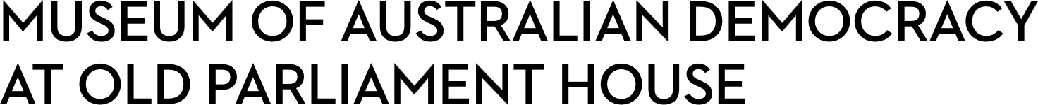
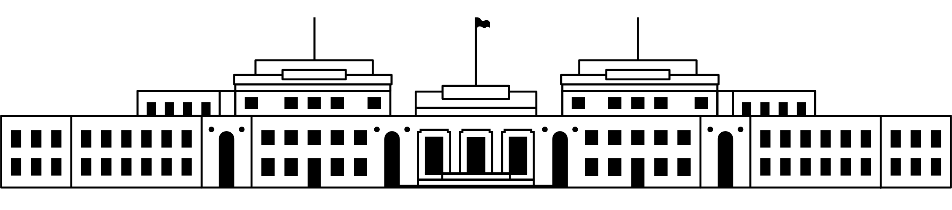

CANDIDATE PACK
POSITION DETAILS
REFERENCE NO | 21900
TITLE | Volunteer and Museum Experience Coordinator
CLASSIFICATION | APS6
EMPLOYMENT TYPE | Non-ongoing for 6 months
WORKING HOURS | Part-time
OFFICE ARRANGEMENT | On-site
SALARY | $94,563 – $105,910 pro rata + 15.4% superannuation + 21.5% commuted penalties.
SECTION | Museum Experience and Learning
TEAM | Museum Experience
ELIGIBILITY | - Australian Citizenship  - Security Clearance (after commencement)  - Working with Vulnerable People (after commencement)
CONTACT OFFICER | Holly Anderson on 02 6270 8159
OPENING DATE | Tuesday 18 November 2025
CLOSING DATE | Sunday 30 November 2025 (11:59pm)
SPECIAL NOTE | Non-ongoing opportunity with the possibility of extension and/or ongoing.  Weekend work required. Occasional afterhours work required.  Suitable candidates may be placed in a merit pool from this selection process and the pool may be used to fill similar ongoing or non-ongoing roles. Non-ongoing vacancies filled from a merit pool may be offered as a specified term.  Applicants may have their application and assessment results shared with other Australian Public Service (APS) agencies looking to fill similar roles.

ABOUT US
The Museum of Australian Democracy (MoAD) at Old Parliament House is located inside a heritage-listed building that was once home to Australia's Parliament (1927 to 1988).
True to our building’s original brief, we provide a ‘people’s place’, where big ideas are explored.
We share the story of Australia's democracy through exhibitions, events and education programs, as well as through our rich online collection of stories, objects and resources.
At MoAD, we celebrate the Australian democratic journey. We seek to provoke thought and inspire conversation by sharing stories and objects that played a part in shaping the nation as it is today.
Careers at MoAD are varied, from human resource officers, exhibition curators, heritage officers and learning facilitators, to digital producers, finance officers and IT specialists. We are a small agency, working in a dynamic environment, sharing our democratic and political history in a heritage-listed building.
MoAD is an inclusive and rewarding workplace that values the contributions of all our staff. We encourage applications from First Nations Australians, people with a disability, culturally and linguistically diverse people and LGBTQIA+ people. We are committed to a safe and supportive workplace which includes flexible working practices.
MoAD employees are engaged under the Public Service Act 1999 and are subject to the terms and conditions of employment in the OPH Enterprise Agreement 2024-2027.

POSITION DETAILS
As part of a small team working in a fast-paced environment, you will be responsible for the day-to-day operations and supervision of the Museum Experience Officers and Volunteers as well as the Museum Experience Supervisor to meet the agency’s Museum Experience objectives.
As a member of a team working in conjunction with other sections, the role includes day-to-day administration of the Museum Experience section, including staffing and workflow, determining daily priorities, mentoring and development of staff and volunteers, and acting as the senior officer on site on rostered weekends and public holidays. This position supports policy development, program development, and implementation of the Museum Experience Section Plan and activities.
This role works in conjunction with another part-time APS6 Volunteer and Museum Experience Coordinator to cover opening hours across seven days a week. This position works 7.5 hours per day on a fixed 15-day roster pattern, including regular weekend shifts (one weekend out of two) and some public holidays. You will receive 21.5% commuted penalties in addition to your base salary each fortnight. In addition, the successful applicant may occasionally be required to work overtime to support operations outside of their rostered hours. Penalty rates will apply for any hours worked in addition to standard hours.

ROLE RESPONSIBILITIES and DUTIES

Under the direction of the Manager Museum Experience the Volunteer and Museum Experience Coordinator will be required to:

- Provide leadership in building and maintaining an effective team of Museum Experience Officers and Volunteers. This includes developing and implementing development programs for the Museum Experience team and Volunteers, training, and performance management.

- Supervise day-to-day coordination of the Museum Experience team and Volunteer program including rostering, identification and resourcing of daily priorities, as well as liaising with other teams, tenants and contractors in co-operation with the Volunteer and Museum Experience Supervisor.

- Weekend supervision of front-of-house operations and delivery of public programs to achieve Museum Experience objectives.

- Lead on development and delivery of new and continuing experiences.

- Lead on training the teams in delivering Museum Experience objectives, including occasionally taking tours to demonstrate effective methods of presentation and support VIP visits. Oversee implementation of training and development programs to upskill the team in using the systems and programs.

- Maintain effective communication with Museum Experience team, volunteers, other teams, contractors and tenants, using a variety of information channels.

- Assist with the preparation and management of budgets, regular reports and other resources, including continuous improvement initiatives and policy development.

- Act as representative of the section for whole-of-organisation offerings as identified.

- Act as System Administrator and/or expert on programs and systems with an emphasis on their use by the Museum Experience team.
OUR IDEAL CANDIDATE

To be successful for this role you will need to demonstrate:

- The ability to think strategically and operationally to support current and future workforce needs.

- Excellent communication (written and oral), presentation and interpersonal skills, including the ability to liaise with prominent external stakeholders.

- Ability to be a team leader, along with high-level management skills to build team cohesion, supervise operations and coordinate staff training.

- Demonstrated ability to show initiative, share knowledge, take on constructive feedback and take responsibility for personal development.

- The ability to work both independently and as part of a team to creatively solve problems, work flexibly, meet deadlines and work to a budget.

- Proficiency in the use of standard ICT tools and the ability and willingness to learn new software.

YOUR APPLICATION
Please provide a:

- concise statement of claims of no more than 2 pages. When framing your statement, please ensure you adequately demonstrate your skills, qualifications, experience and capabilities.

- Resume outlining your career history, qualifications and contact details for at least two recent referees (no more than 4 pages).

- coversheet from the MoAD Website.

MoAD accommodates requests for reasonable adjustment for people with disabilities to participate in an interview, including offering onsite tours to potential employees before their interviews to gauge any possible access barriers and to comfortably see staff spaces before committing to interview or the job position. Please indicate this in your cover sheet or contact the recruitment officer on 02 6270 8235 or 02 6270 8127.

ELIGIBILITY
To be eligible for this position at MoAD, applicants must:
- be an Australian Citizen; and

- have a security clearance or be willing to undertake the process to obtain a baseline clearance (after commencement); and

- have, or be willing to undertake the process to obtain, a Working with Vulnerable People registration; and

- be willing to provide identity documents and undergo an identity pre-employment check through a Document Verification Service, if you are deemed to be the successful candidate.

SUBMISSION OF APPLICATION
Your application should be submitted by the closing date to applications@moadoph.gov.au

For noting:

- Your application will be automatically acknowledged. If you do not receive an automated receipt, please contact 02 6270 8235 or 02 6270 8127 or email recruitment@moadoph.gov.au

- Applications received after closing will not be accepted unless a prior arrangement has been made with the contact officer

