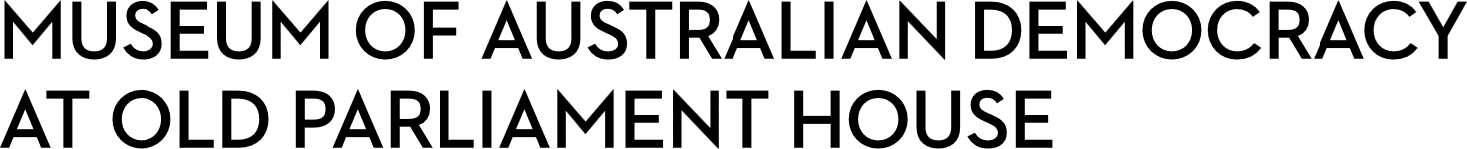
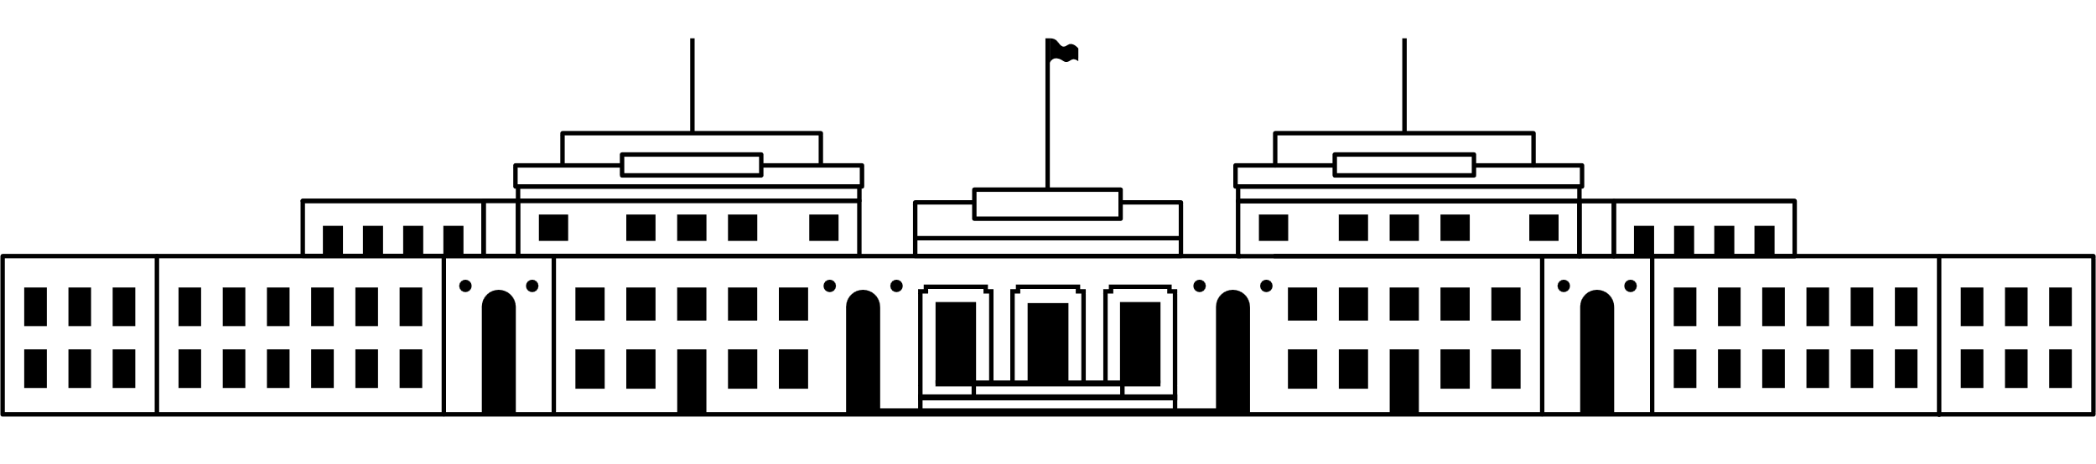

CANDIDATE PACK
POSITION DETAILS
REFERENCE NO | New Position
TITLE | Assistant Curator – Centenary Projects
CLASSIFICATION | APS level 4
EMPLOYMENT TYPE | Non-Ongoing Specified Task
WORKING HOURS | Full-time
OFFICE ARRANGEMENT | On-site with work from home options available
SALARY | APS 4 $75,385 – 81,775 pa + 15.4% Superannuation
SECTION | Curatorial and Interpretation
TEAM | Research, Collections and Curatorial
ELIGIBILITY | - Australian Citizenship  - Baseline Security Clearance (after commencement)
CONTACT OFFICER | Lara Nicholls  02 6270 8146
OPENING DATE | Thursday 5 February 2026
CLOSING DATE | Wednesday 18 February 2026
This is a non-ongoing Specified Task opportunity until the end of the centenary program in late 2027.
Suitable candidates may be placed in a merit pool from this selection process, and the pool may be used to fill similar non-ongoing roles. Non-ongoing vacancies filled from a merit pool may be offered as a specified task.

ABOUT US
The Museum of Australian Democracy (MoAD) at Old Parliament House is a contemporary museum located in a heritage-listed building that was home to Australia's Parliament from 1927 to 1988.
True to our building’s original brief, we provide a ‘people’s place’, where big ideas are explored.
We share the story of Australian democracy through exhibitions, events and education programs, as well as through our rich online collection of stories, objects and resources.
At MoAD, we celebrate the Australian democratic journey. We seek to provoke thought and inspire conversation by sharing stories and objects that played a part in shaping the nation as it is today.
Careers at MoAD are varied, from human resource officers, exhibition curators, heritage officers and learning facilitators, to digital producers, finance officers and IT specialists. We are a small agency, working in a dynamic environment, sharing our democratic and political history in a heritage-listed building.
MoAD is an inclusive and rewarding workplace that values the contributions of all our staff. We encourage applications from First Nations Australians, people with a disability, culturally and linguistically diverse people and LGBTQIA+ people. We are committed to a safe and supportive workplace which includes flexible working practices. MoAD’s commitment to reconciliation is expressed in the MoAD Reconciliation Action Plan 2023-25.
MoAD employees are engaged under the Public Service Act 1999 and are subject to the terms and conditions of employment in the OPH Enterprise Agreement 2024-2027.

POSITION DETAILS
Old Parliament House is a heritage building located on a site of great historical significance for all Australians. To mark its centenary in 2027, MoAD is developing a suite of innovative programs including an important exhibition about First Nations Peoples’ and Australian democracy. This exhibition will support the sharing of First Nations histories and stories through their diverse voices.
Working in a small but dedicated team of First Nations curatorial staff and the Senior Curator– Centenary Projects, the Assistant Curator will play a pivotal role in the development and delivery of this timely exhibition. Our work on this exhibition is also guided by a First Nations Advisory Committee. You will be a skilled researcher who has worked with cultural objects and/or works of art in museum settings and who knows how to tell inspired stories which cross between politics, social history, cultural heritage, and the arts. The curatorial team are highly consultative and community-orientated so the Assistant Curator will enjoy working collaboratively with a wide range of people from all walks of life. You will have an aptitude for exhibitions and curatorship and appreciate the powerful way exhibitions can tell stories about the diverse experience of citizenship and democracy in Australia.

ROLE RESPONSIBILITIES and DUTIES

Working under the direction of the Senior Curator, the APS 4 Assistant Curator (First Nations) will:
- Support the work of the First Nations curatorial team and assist with research and development of the curatorial scheme.

- Develop exhibition and interpretive content for onsite and online visitors including wall texts, object labels, and digital content.

- Carry out focused research using MoAD’s collection, materials from other cultural institutions, and input from stakeholders, including First Nations communities and the non-indigenous public.
- Assess the provenance, cultural context and significance of objects that might be featured in MoAD exhibitions and/or acquired for the collection.
- Work collaboratively with internal teams and external contacts and professionally represent MoAD.
- Contribute to public programs associated with the exhibition.

OUR IDEAL CANDIDATE

The ideal candidate has experience working in public galleries and/or museums and collection management systems. They are storytellers who enjoy working with people, objects and places to create engaging experiences for onsite and online museum visitors.

The qualities that we are seeking for this position are outlined below:

- Tertiary qualifications and a strong interest in First Nations art and culture, Australian social, political and democratic history, museum studies, or a related discipline are essential.

- Some experience working in a museum or gallery setting is essential.

- Excellent organisational skills and an ability to set and manage priorities and complete tasks in a timely and thorough manner.
- Demonstrated and well-developed communication skills.

- Demonstrated ability to work in a team and with diverse stakeholders including experience working with First Nations people and organisations is highly desirable.

- Ability to use a range of applications including standard ICT tools such as Microsoft Word and Microsoft Outlook, and collection management systems such as KE Emu, and an ability and willingness to learn new software.

YOUR APPLICATION

Please provide a:

- concise statement of claims of no more than 2 pages which specifically addresses the key points listed under ‘Or Ideal Candidate’. When framing your statement, please ensure you specifically demonstrate your skills, qualifications, experience and capabilities with examples from your work/life experience in relation to the Role Responsibilities and Duties.

- Resume outlining your career history, qualifications and contact details for at least two recent referees (no more than 4 pages).

- coversheet from the MoAD Website. Please note when you complete the coversheet, please indicate which role you are applying for.

MoAD accommodates requests for reasonable adjustment for people with disabilities to participate in an interview, including offering onsite tours to potential employees before their interviews to gauge any possible access barriers and to comfortably see staff spaces before committing to interview or the job position. Please indicate this in your cover sheet or contact the recruitment officer on 02 6270 8235 or 02 6270 8127.

ELIGIBILITY
To be eligible for this position at MoAD, applicants must:
  - be an Australian Citizen; and
  - have a security clearance or be willing to undertake the process to obtain a baseline clearance (after commencement).

  - be willing to provide identity documents and undergo an identity pre-employment check through a Document Verification Service, if you are deemed to be the successful candidate.

SUBMISSION OF APPLICATION
Your application should be submitted by the closing date to applications@moadoph.gov.au

For noting:
- Your application will be automatically acknowledged. If you do not receive an automated receipt, please contact 02 6270 8235 or 02 6270 8127 or email recruitment@moadoph.gov.au

- Applications received after closing will not be accepted unless a prior arrangement has been made with the contact officer

